LAMS: Pre-Service Teachers Update the Old Lesson Plan

Leanne Cameron
Australian Centre for Educational Studies, Macquarie University
Australia
Leanne.Cameron@mq.edu.au

Abstract: The value of a lesson plan as an organisational tool is highly regarded by many teacher educators but from a pre-service teacher’s point of view, it often produces little more than “documentation”, hence their reluctance to undertake them. The Teacher Education Program at Macquarie University is trialling the use of LAMS software as a scaffold for lesson planning with pre-service teachers. The graphic interface allows students and their tutors to visualise lessons providing an instant “picture” of the lesson and its content with a clarity not available in traditional written lesson plans. Throughout the process of authoring a LAMS sequence, these students are required to think about all aspects of their lesson and LAMS enables them to experience the lesson themselves via a Preview mode before using it in the classroom. In addition, LAMS creates these lessons in a standardised template of activities that can easily be modified for future re-use.

Introduction

The amount of detail included in a lesson plan varies with the individual teacher and his/her experience. Pre-service teachers are advised to provide very specific details to enable them to have a very clear understanding of every aspect, and the sequence, of the lesson. And the question that pre-service teachers inevitably ask is, “Does writing a lesson plan really make my lesson any better in the classroom?” Whilst many experienced teachers may not create formal lesson plans before every lesson they teach, to the pre-service teacher lesson plans are an essential planning tool (Capel, 1997). The value of a lesson plan as an organisational tool is highly regarded by many teacher educators but from a pre-service teacher’s point of view, they often produce little more than “documentation”, hence their reluctance to undertake them.

Lesson plans usually document lesson outcomes, appropriate learning activities sequenced in a logical order, assessment tasks and lesson evaluation criteria (McCutcheon, 1980). Written planning is required of most teachers but particularly those new to the profession (Moyles, 1995) because they ensure teachers are better prepared for instruction; enable them to consider different options and to be more flexible; they assist with evaluating instruction; and they help teachers to build up confidence in their teaching (Marsh, 2004).

A lesson plan is a professional document explaining what will happen in a particular timeframe (Whitton, 2004). Although statutory bodies determine what students learn and at what stage, it is still very much the prerogative of the classroom teacher, within the framework decided in the school as a whole, as to what students do each day. As there is perhaps no other single function that a teacher must perform that threatens to take as much time, effort, and energy outside of the classroom as the writing of a lesson plan (Kelly, 1997), in a recent study at Macquarie University, teacher educators set out to review the benefits, if any, of creating lesson plans using a computer-based graphical interface over writing traditional lesson plans. In the study pre-service teachers were asked to create lesson plans using LAMS (Learning Activity Management System) software that were not simply “documentation” but fully operational lessons.

Background

The current study evaluated the use of LAMS as a scaffold for lesson planning with 255 pre-service teachers (152 females and 103 males) over 4 Semesters in the 2006 and 2007 Academic years. This analysis built on a pilot study which was undertaken in 2005 with 94 pre-service teachers (28 male and 66 female) to evaluate. Each student was asked to construct a learning sequence using LAMS software and to write a justification for the design and pedagogy used in his/her sequence. They were required to use the literature to support their approach and activity choices. The main purpose of this assignment was to establish students understood the pedagogical concepts involved in their lesson design.

None of the students who took part in the study had had any previous experience with the LAMS software. To provide these students with some experience with LAMS before they were asked to author their own sequence, tutors delivered selected course content via LAMS sequences on four separate occasions and gave them an opportunity to de-construct LAMS sequences selected from the LAMS Community website (www.lamscommunity.org). Tutors then provided students with basic LAMS instruction in authoring. Following this, class time was provided so students could begin their sequences under the supervision of their tutor, but students were encouraged to collaboratively work through issues as they arose with their peers. Before final submission, students were given a further opportunity in class to workshop their sequence with their peers during which time they were encouraged to collaboratively work through any perceived difficulties.

Of the 349 students involved in the trial, only one student was not able to successfully construct an operational LAMS sequence by the end of the course. When a sample of the students was surveyed, 93% said they would use LAMS again to construct a lesson if given the opportunity. This figure surprised the tutors, as a number of unforeseen technical difficulties had arisen during the course making the authoring experience quite challenging at times.

Method

A survey was completed by a random selection of 120 students from this group of pre-service teachers. The questions focussed on whether LAMS facilitated the creation of their lesson plans in the following four areas:

- planning all aspects of their lesson;
- previewing their lesson from the learners’ perspective;
- providing a visual overview of the lesson to identify the learning styles addressed with the activities employed; and
- creating a standardised template of activities that could be easily modified for future re-use.

The following table outlines the questions used and the participants’ responses.

Questions | Responses
Planning all aspects of their lesson | Positive | Neutral | Negative
Did the amount of detail required to complete a LAMS sequence help you construct this lesson, or do you think you would have covered all the steps regardless? Explain your answer. | 49  (82%) | 2  (3%) | 9  (15%)
Would you consider using LAMS to design a lesson again?  Why / Why not? | 39  (65%) | 15  (25%) | 6  (10%)
LAMS Version 2 has the facility to record online and offline tasks so it could be used as a lesson plan creator. Would this be preferable to you than manually writing / typing your lesson plan? * | 56  (93%) | 1  (2%) | 3  (5%)
Previewing their lesson from their learners’ perspective
How effective did you find the ability to preview your lesson from a student’s perspective? | 58  (97%) | 2  (3%) | 0
Was the workshopping of the sequences a worthwhile experience? Why? / Why not? | 55  (92%) | 1  (2%) | 4**  (6%)
Providing a visual overview of the lesson to identify the learning styles addressed with the activities employed
Did having the LAMS activity tools on the screen help you choose the learning activities for your sequence? | 56  (93%) | 2  (3%) | 2  (3%)
Did you find being able to overview your whole sequence in Author (Version 1) influenced your choice of activities or the lesson flow? | 50  (83%) | 0 | 10  (17%)
Do you think the coloured icons used in LAMS Version 2 might influence the design of your lesson in the future? Please explain your answer. | 51  (85%) | 1** (2%) | 8  (13%)
Creating a standardised template of activities that could be easily modified for future re-use
Assuming you have the facilities, do you think you might re-use your LAMS sequence in the future? Why? / Why not? | 59  (98%) | 0 | 1  (2%)
Can you see any advantages / disadvantages to re-using a LAMS sequence over re-using a written lesson plan? | 49  (82%) | 11  (18%) | 0

Table 1: Survey questions and calculated participants’ responses

*Although this new feature was described to the subjects of the study, they were not given the opportunity to work with it.
** Some participants were absent for this session so could not comment.

Discussion

The results reported above resoundingly confirm that using LAMS to plan lessons has a number of advantages over writing a traditional lesson plan:

1. LAMS helped student plan all aspects of their lesson

The majority of the students (82%) agreed that using LAMS helped them to comprehensively construct their lesson. From the tutors’ previous experience with similar courses, they have come to expect many pre-service teachers will initially have difficulty developing lesson plans of good quality. Frequently these plans contain too little detail and the students have not thought about including a variety of pedagogical approaches. The lack of detail often adds uncertainty upon the delivery of the lesson in the classroom and repetitive teaching strategies are not always engaging to the learners. This, in turn, undermines the confidence of the pre-service teacher.

A major advantage with creating a lesson in LAMS is that it provides a framework for lesson designers to reflect in a deeper and more creative way about how they design and structure activities for different learners or groups of learners (Britain, 2004). There are a variety of tools incorporated into LAMS which focus on providing activities that help create deeper, swifter and more effective learning. 93% of those surveyed found that the tools offered by LAMS helped them choose a variety of activities for the classroom. As one student commented,

“It visually showed me what was available to use and thus allowed me to trail things I may not have realised I could use and see more suitable activities.”

The collaborative tools were found to be a particularly powerful means of encouraging learners to think deeply about their topic but, in the tutors’ experience, many pre-service teachers do not often consider these tools when designing lessons. By having these tools available on the screen, LAMS encourages their use.

“I wouldn’t of thought about using Chat, Forums, etc. I found LAMS helpful for new ideas.”

Throughout the process of authoring a LAMS sequence, the pre-service teachers were required to think about all aspects of their lesson. Each time an activity was selected, a dialogue box prompted them to supply all the required detail needed to complete the activity (see Figure 1). It was frequently during this process that our students realised they did not have a deep enough understanding of the content they were attempting to teach and further research was required. The time for further research is rarely available once the lesson has been commenced in the classroom.

“The amount of detail did help me construct my lesson plan. The detail helped me to organise my ideas on how I wished the lesson to go, but also provided me with what kind of activities could be used.”

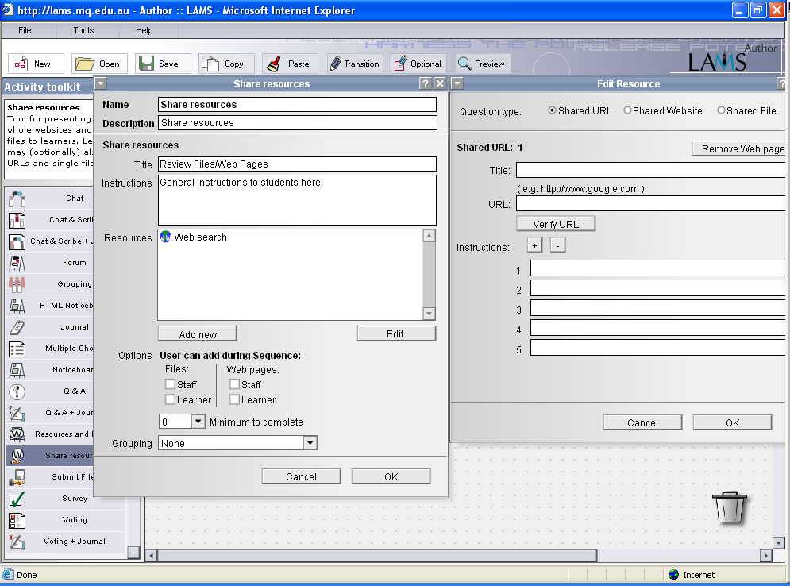

Figure 1: An example of the information required to activate a LAMS Activity tool.

The students agreed that fully developing a LAMS sequence with all the necessary detail is a time-consuming process but as each piece of information needed is quite specific in its purpose, the completion of the sequence did not seem as tedious as completing a very detailed written lesson plan with its far more open-ended structure. Additionally, students realised that each carefully considered entry was working toward producing a fully operational lesson, not just a paper-based outline that still had to be translated into a lesson.

2. LAMS allowed the pre-service teachers to preview their lesson from the learner’s perspective

The LAMS visual environment readily allows users to design their own online lessons and immediately “picture” how they will appear to the learner. It enables them to experience the lesson themselves from a learner’s perspective before using it via a Preview mode exactly as the learner would see it. In this way, the pre-service teacher experiences the lesson and can identify any difficulties with it before trialling it in the classroom. This was a very popular feature with participants: 97% found this feature very effective:

“Being able to view the sequence, you can see where you need to make changes. Whilst creating the sequence you are viewing it form an author’s perspective, whilst when you preview the sequence, you are seeing it from a learner’s perspective. After all, we are creating these sequences for learners to use. So this is vital.”

Awkward sequencing is frequently picked up at this point and because LAMS sequences are simple to edit, the lessons can be readily modified. The sequencing of activities can often be vital to the success of a lesson and within the LAMS authoring environment, explicit sequencing is simply achieved. Conversely, some of the participants enjoyed providing their learners with a choice of activity order, and this often empowered the learner, making the sequence more enjoyable. Preview also gave the pre-service teacher the opportunity to trial a variety of possible activities. The feature provided them with the ability to work through these alternative approaches and decide which works best or give the learner the option of choosing their own preferred path.

3. LAMS provides a visual overview of the lesson which can identify the learning styles addressed with the activities employed

The LAMS graphic interface enabled the pre-service teachers and their tutors to “visualise” lessons providing an instant “picture” of the lesson and its content with a clarity not available in other lesson plans. 83% of those surveyed agreed that being able to overview their sequence influenced their choice of activity or lesson flow. As each type of LAMS activity is represented by a unique icon, its location in the lesson sequence and its frequency can be quickly identified.

To further capitalise on this “visual” approach, several tutorial groups in the 2005 pilot were encouraged to colour the individual activities in their sequence according to learning activity type. In this way, the variety of lesson activities used in the LAMS sequence could be determined at a glance and the students were left in no doubt as to how to include a range of activities in their lesson. This feature has been incorporated into LAMS Version 2. The majority of students (85%) found looking at the coloured activity icons enlightening:

“It gives you a visual perspective of how your lesson varies and whether you might have too much of one activity or not enough of another. I think the colours are a really clear indicator of the structure of the lesson.”

It is interesting to contrast the screen shot of a LAMS lesson plan below, the more traditional lesson plan.

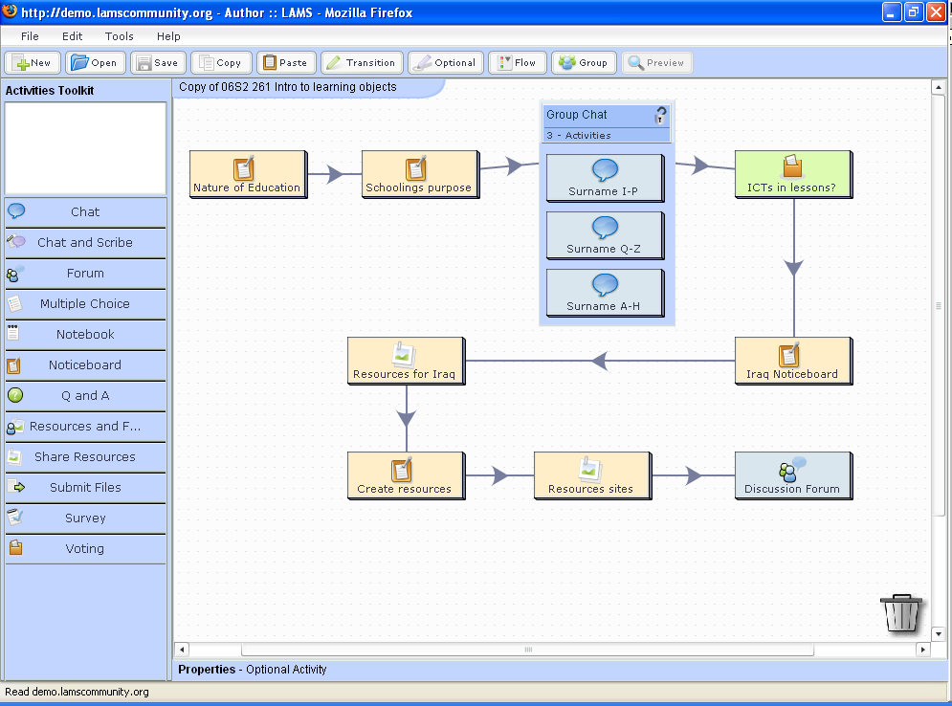

Figure 2: A lesson in LAMS Version 2.

Written Lesson Plan Example
Class: 9 | Date: 27/6/06 |  | Period:3/4 | Period Start: 10:39 | Period End: 1:14
Topic: |  | Statistics
Syllabus Outcomes: |  | DS5.1.1 groups data to aid analysis and constructs frequency and cumulative frequency tables and graphs.
Student Outcomes: |  | Can recognise different types of data graphs (column, frequency, step, scatter plot, dot plot, box-and-whisker, line).  Can represent data using different graphs.  Can use a graphics calculator to display data as a histogram or a box plot.
Link with Previous Learning: |  | Data collection, pie charts, step graphs, stem-and-leaf plots, mean mode & median.
Resources: |  | Worksheets * 30 – chalk
Assessment: |  | Homework, class exercise observation, questioning.
Lesson Plan
Stage: | Teacher activity: | Student activity:
Revision  20 mins | Introduce yourself! Mark the roll and set the rule of name before answer!  Summarise what they remember of data representation. For each graph using numbers 3, 5, 6, 8. 8 display on the board. | Students can represent data using frequency histograms, step graphs, scatter plot, dot plot, box-and-whisker, and line graphs and know which is applicable to one variable which is useful for 2-var!
Worksheet  15 mins | Hand out the worksheet to do the exercise on the sheet. In the last two minutes go through the answers. | Start answering the questions on the worksheet with the given data set.
Graphics calculator  25 mins | Hand out the calculators and instruction sheets. | Get started on using the calculator following the instruction sheet!
Homework  15 mins | Exercise from textbook, doing every second column. | Quietly writing homework in their homework book ☺
Homework: text book ( ) ☺

Figure 3: A “traditional” lesson plan

A visual approach to lesson planning has previously been successfully trialled using Concept Maps. Fullan & Miles (1992, as quoted in Kinchin, 2005) reported the concept mapping approach helped the pre-service teacher go beyond a mastery of content and examine how best it can be transmitted, toward an appreciation of pedagogy and how understanding can be variously constructed by student. It provided a concrete, practical tool that related directly to the everyday operation of their classrooms. Our study similarly found our students moved their focus to pedagogy when constructing their LAMS sequence.

4. LAMS creates a standardised template of activities that could be easily modified for future re-use

The students immediately saw the potential of re-use. In fact, assuming they had the facilities, 98% said they might re-use their LAMS sequence in the future:

“Yes, I would re-use it. I really liked the way my sequence turned out. It could be used in more than one way. With a minimum of adjustments I could use this sequence in a number of different ways.”

Although teachers have a long tradition of sharing their written lesson plans, there has not been a formal vocabulary established to help standardise and add consistency to their descriptions (Beetham, 2006). This could potentially lead to a misunderstanding of some of the nature of the lesson. By designing lessons using standardised activity icons, LAMS is able to overcome much of this problem. The pre-service teachers liked the fact that their LAMS sequences could maintain a consistency that traditional lesson plans could not:

“The advantage is you can be more confident it will run exactly the same as last time so you can fix the bits that didn’t work and re-use the bits that did.”

Beetham (2006) sees re-use as the way of the future.

Lesson designers will want learning design tools that will support the following:

- The ability to adapt designs responsively;
- The ability to collectively author and share designs;
- Explicit representation of underlying approaches or pedagogies to support their own personal development.

When our students visited the LAMS Community website (www.lamscommunity.org) and trialled lessons that worked but were not in their subject area, they could see how simply the content could be modified and the sequence made to work for them. Bennett (2004) proposes that “generic” lesson plans could serve as a pedagogical framework to support teachers in creating learning experiences, with the teacher adapting the learning design, specifying the particular activities and choosing or creating the resources and supports needed to suit his/her students. In this study we have shown that our students believe LAMS is up to the challenge.

Conclusion

The trial with Teacher Education Program students at Macquarie University using LAMS as a scaffold for lesson planning produced extremely positive results. These students created well-documented lessons that illustrated a level of detail and a variety of activity that is often missing in the written lesson plans of pre-service teachers.

The combination of the pop-up windows asking for specific activity detail plus the coloured graphic interface enabled our students to preview and overview lessons in a way not possible with traditional lesson plans. Additionally, LAMS created these lessons in a standardised template that can be easily modified for future re-use. The ability to readily re-use lessons presents new possibilities for increasing the quality and variety of teaching and learning within an e-learning context.

References

Beetham, H. (2006). Design for Learning. Online discussion at JISC Innovating e-Learning 2006: Transforming Learning Experiences Online Conference.
Bennett, S., Lockyer, L. & Agostinho, S. (2004). Investigating how learning designs can be used as a framework to incorporate learning objects. Paper presented at the Beyond the comfort zone: Proceedings of the 21st ASCILITE Conference, 5-8 December, Perth.
Britain, S. (2004). A Review of Learning Design: Concept, Specifications and Tools. A report for the JISC E-learning Pedagogy Programme.
Capel, S., Leask, M., & Turner, T. (1997). Starting to teach in the secondary school: A companion for the newly qualified teacher. London: Routledge.
Dalziel, James (2006) Lessons from LAMS for IMS Learning Design. Macquarie E-learning Centre of Excellence (MELCOE)
Dalziel, J.R., (2005) From Re-usable e-Learning Content to Re-usable Learning Designs: Lessons from LAMS. Macquarie E-learning Centre of Excellence (MELCOE)
Dalziel, J.R., (2003) Implementing Learning Design: The Learning Activity Management System (LAMS) Macquarie E-learning Centre of Excellence (MELCOE)
IMS Global Learning Consortium, Inc., (2006). IMS Frequently Asked Questions. http://www.imsglobal.org/faqs/imsnewpage.cfm?number=4
Joint Information Systems Committee (2006). JISC Circular 01/06: Design for Learning Programme. http://www.jisc.ac.uk/index.cfm?name=funding_01_06
Kelly, K.B. (1997) Role of lesson plans in instructional planning. Paper presented at the Annual Reading/Literacy Conference (8th, Bakersfield, California, August 22-23, 1997)
Kinchin, I.M. and Alias, M. (2005) Exploiting variations in concept map morphology as a lesson-planning tool for trainee teachers in higher education. Journal of In-service Education, Vol. 31, No. 3. pp. 569-591.
Koper, R. (2006). Current Research in Learning Design. Educational Technology & Society, 9(1), pp. 13-22.
Marsh, C. (2004). Becoming a teacher: understandings, skills and issues. Frenchs Forest, NSW: Pearson Education Australia.
McCutcheon, G. (1980). How do elementary school teachers plan? The nature of planning and influences on it. The Elementary School Journal, 81(1), 4-23.
Moyles, J. E. (1995). Beginning teaching: Beginning learning in primary education. Buckingham: Open University Press.
Oliver, R. & Littlejohn, A., (2006). Discovering and Describing Reusable Practitioner Focussed Learning Designs. Paper presented at JISC Innovating e-Learning 2006: Transforming Learning Experiences Online Conference.
Weiner, L. (1997) Designing lesson plans: What new teachers can learn from Moffett and Wagner. The English Journal, Vol. 86, No. 4. Literary Festival. (April), pp. 78-79.
Whitton, D., Sinclair, C., Barker, K., Nanlohy, P., & Nosworthy, M. (2004). Learning for teaching: Teaching for learning. Southbank, Vic: Thomson Social Science Press.

