Sharing and Re-Using Effective Student Centred Learning Designs

Professor James Dalziel,
Director, Macquarie E-Learning Centre Of Excellence (MELCOE)
Macquarie University, Sydney, Australia
james@melcoe.mq.edu.au

ABSTRACT
The new field of Learning Design provides frameworks and systems for describing sequences of student-centred learning activities. For students, Learning Design offers opportunities for greater engagement and collaboration than traditional content-centric approaches. It can also provide better scaffolding for student collaboration through carefully structured sequences of learning activities. For educators, Learning Design can not only improve student engagement, but also allows for sharing of "good e-Teaching ideas" among educators. By sharing effective templates and exemplars, many educators can re-use and adapt Learning Designs developed by experts. This presentation will discuss the benefits of Learning Design for student centred learning and teaching, including the potential for sharing of best practice among educators, including case studies from the implementation of LAMS in universities in Australia, the UK, Singapore and Japan.

Introduction

Learning Design is the name given to a new field of e-learning which focuses on the description and sharing of sequences of learning activities (Agostinho et al, 2002; IMS, 2003; Koper, 2001). There are a number of different definitions of Learning Design, but they generally involve the use of an agreed framework to describe sequences of learning activities (where “sequence” is defined broadly to include multiple pathways and non-linear teaching strategies in addition to step by step approaches). Individual learning activities within a sequence can be described in terms of the roles involved (eg, teacher, learner), the resources required (eg, websites, articles) and “environments” (in an online context, this would be tools such as forums, quizzes, chat, etc). A sequence can also incorporate descriptive metadata (eg, Dublin Core, IEEE LOM).

Taken together, these qualities of an individual Learning Design (hereafter a “sequence”) when applied to a particular discipline topic allow for it to be used directly for teaching students. In the case of e-learning, a sequence can be automatically “run” by a Learning Design system which sets up activity tools and manages the progress of students. While a teacher may create a sequence that they then use with their own students, the greatest promise of Learning Design as a field is the potential for sharing of sequences of “good e-Teaching ideas” among educators, in particular, the potential for expert designers to create effective sequences which can then be widely disseminated to other educators (eg, Dalziel, 2007).

Learning Design is not a pedagogical theory in the traditional sense – it does not posit particular theories about how students learn, nor does it direct teachers towards particular teaching methods. Instead, it is a more general framework for describing the activities of teachers and students over time using a structured language about the use of resources and tools for learning. It aspires to be “pedagogically neutral” (Koper, 2001) in the sense that the descriptive framework should be able to describe many different teaching and learning approaches, which themselves instantiate different theories about how students learn.

In one sense, the goal of Learning Design is more modest than a traditional pedagogical theory, in that it does not attempt to describe what a teacher “ought” to do (given the assumptions of a particular theory); on the other hand, its goal reaches beyond typical theories in that it tries to provide a “meta-model” capable to describing teaching and learning activities from many different pedagogical theories within a single framework.

One important aspect of Learning Design compared to past e-learning approaches is its broader view of student activities – specifically, the potential for collaborative learning (Conole, 2009). There are many examples of e-learning which are based only on a “single learner” context – that is, the learner works through specified content in isolation from other students. While there are some contexts in which this style of e-learning would be appropriate (or necessary due to constraints of time and location), it would be unfortunate if e-learning theories were based solely on a “single learner” approach.

Learning Design, through its explicit acknowledgement of different roles (such as teachers and learners, and even different types of learner roles within a group of learners – such as a discussion leader, note taker and discussant in a group discussion activity) draws attention to the potential for group activities and interactions between teachers and students, as well as being able to describe single learner contexts. From this it can be argued that the field of Learning Design is a superset of the field of Instructional Design, in that it provides a descriptive framework that covers the typical approaches of Instructional Designs, as well as the ability to also describe group-based student tasks and interaction between teachers and students. However, while Instructional Design is a long-standing and richly described area of study, Learning Design, by comparison, is relatively new and under-developed.

Why consider collaborative learning?

As Learning Design aspires to neutrality about pedagogical theories, it is appropriate to consider the pedagogical rationale for collaborative learning (as the mere capability of describing collaborative learning within Learning Design does not, in itself, justify its use). It is not just e-learning that has been heavily focussed on “single learner” contexts – much of traditional education, such as lectures, essay writing and exams generally do not involve student collaboration.

There is not space here to provide a detailed review of recent approaches to student learning and collaboration, but in brief, there is a growing body of work that explores the motivations for student learning, the engagement of students in their learning, the extent to which students play a role in determining their own learning, the active construction of meaning by students, the importance of authentic assessment tasks for students and the alignment between learning activities and appropriate assessment. Authors such as Diana Laurillard, Graham Gibbs, Paul Ramsden, John Biggs, David Boud, David Kolb and many others have discussed ways in which traditional educational approaches can be changed to increase student motivation and their active engagement with learning. Many of the new approaches involve group-based learning with collaboration between students and teachers and among students.

It is worth noting that many collaborative approaches take more time to cover a given topic (relative to a typical lecture) and hence there can be concerns about a loss of breadth of information provided about a discipline when a collaborative activity is used – that is, the collaborative activity may provide for greater depth of understanding of a particular topic, but at the expense of time that might otherwise have been used to cover more topics. There can also be concerns about the amount of time required from teachers to facilitate collaborative activities, as well as problems arising from unequal student participation in collaborative tasks.

While there may be reasonable justifications for these concerns, they need to be viewed in the wider context of modern student learning, in particular, the importance of students developing “generic” skills (such as critical thinking, literacy, problem-solving, teamwork, etc), and the unfortunate reality that much of the discipline content that students learn during a course is rapidly forgotten after exams. Many employers (and others in society) value education for the way that it helps students to think, rather than just specific discipline knowledge. In addition, discipline knowledge is growing so rapidly in many fields that it is very difficult to cover all the relevant material, and in any case, modern searching techniques may make it feasible to quickly research information as it is needed.

Taken together, the need for generic skills and the explosion of discipline knowledge provide a justification for changing current educational approaches away from simply trying to cover all discipline knowledge with information-dense lectures, and towards a more general overview of discipline knowledge combined with collaborative learning activities on major illustrative issues within a discipline.

Learning Design can promote the adoption of collaborative learning by providing effective sequences of student activities that can be easily adopted and adapted to address specific discipline topics. These sequences are based on theories and research of particular methods of collaborative learning developed by expert educators. The following section describes two exemplars/templates which could be used to promote collaborative learning in many disciplines. The examples will be given using online technology based on the author’s work on an open source Learning Design system called LAMS (Dalziel, 2003).

Example 1: Open Questions for Lectures

It can be challenging to maintain student engagement during an information-dense lecture. One way to address this is to pose open questions to students about the topic of the lecture – this allows students to actively engage their current understanding with the questions proposed, and where answers are shared with the lecturer, it allows the lecturer to provide feedback on misunderstandings or expansion of additional details (and when answers are shared publicly, it allows other students to consider the answers given). Student answers to open questions can also be useful for lecturers as an indicator of the level of student understanding about the relevant topic, and whether the lecturer should cover the information in more (or less) depth.

While open questions can be used in a face to face setting, students may feel reluctant to answer due to shyness or concern for making a mistake in front of their peers; alternatively, if many students were to answer, it may take a considerable amount of time to cover many answers. One solution to these problems is to use a simple sequence in a Learning Design system which presents students with a few key questions that require a short answer (typically one or two sentences). After students answer a question, all student answers are collated onto a single screen viewable by all students, and these answers can be presented anonymously (to avoid potential embarrassment).

This approach allows students (and the lecturer) to quickly see a range of different answers. In those disciplines with many possible answers, these answers could be used to illustrate the wide range of views among the student body, while in those disciplines with definitive answers, incorrect answers could be used as a basis for illustrating common misunderstandings of key ideas. In either case, this approach can increase student engagement due to the need for students to answer the question for themselves, as well as providing the lecturer with example answers drawn immediately from the student body that can be used to illustrate important ideas (or mistakes).

This open question sequence can be used during a lecture if enough students have online access (such as from an internet connected smartphone). It is not necessary for all students to participate – just enough students to provide material for the lecturer to review and discuss – this could be as few as ten students. Another approach is for students to be given a set of questions to answer between lectures, with the lecturer then displaying the answers during the next lecture as a basis for illustrating key ideas and/or misconceptions.

While many different sequences could illustrate the approach described above, the following is a typical example. It is provided as a template with advice to the lecturer on how to frame the questions. The figure shows this sequence from the LAMS Authoring environment.

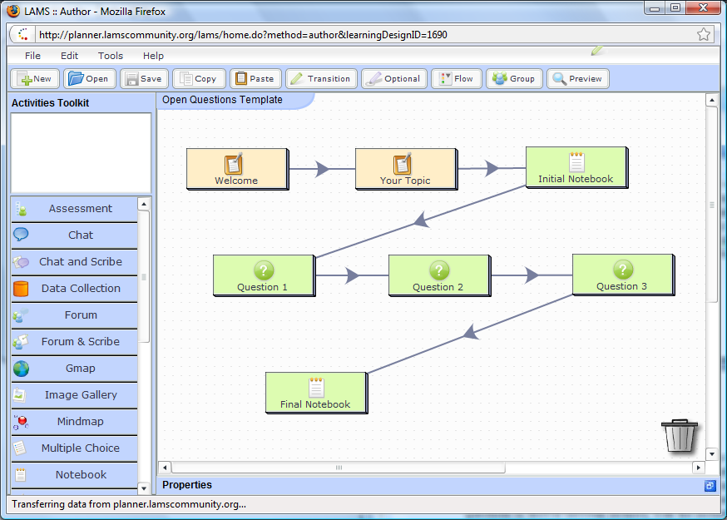
Figure 1: Template for Open Questions in Lectures shown in LAMS Authoring environment.

Step 1: Welcome [Text page]
Introduction describing the seven steps of the sequence. No editing required by lecturer.

Step 2: Your Topic [Text page]
Brief introduction to the topic of the questions – written by lecturer.

Step 3: Initial Notebook/Journal [Private area to record student ideas – not seen by other students]
Asks student to record his/her initial ideas about the topic. This is to help activate student engagement with the topic prior to the open questions.

Step 4: Question 1 [Question & Answer tool – re-presents all student answers anonymously]
Asks student to answer a question written by the lecturer. The lecturer is encouraged to begin with a general, open question to make it easy for students to start answering.

Step 5: Question 2 [Question & Answer tool – re-presents all student answers anonymously]
Asks student to answer a question written by the lecturer. The lecturer is encouraged to make the second question more specific about the topic.

Step 6: Question 3 [Question & Answer tool – re-presents all student answers anonymously]
Asks student to answer a question written by the lecturer. The lecturer is encouraged to make the third question either another specific question, or alternatively a negative statement about the topic that requires the student to answer in a different way to the previous questions.

Step 7: Final Notebook/Journal [Private area to record student ideas]
Asks student to record their final thoughts about the topic. This is to help students synthesise and consolidate their ideas on the topic based on their own answers and those of other students.

This sequence can be used to increase student motivation during lectures or other similar contexts. Using answers from the students themselves can enhance engagement and foster a student-centred approach to learning. As a sequence, it is relatively simple to edit and implement, and does not take a great deal of time to run (although an extended discussion of answers by the lecturer could be appropriate). It may be a particularly appropriate starting point for lecturers and students who are unaccustomed to collaborative learning, and could be used on many occasions throughout a course with appropriate variations in content (and potentially small variations in questions style – such as replacing open questions with “Voting” questions or quiz items).

A “runnable” version of this sequence (for use in LAMS) is available from:
http://www.lamscommunity.org/lamscentral/sequence?seq_id=924466

Example 2: Online Role Play

The second example is a more advanced pedagogical method than the first, based on the concept of a role play. In a role play, each student takes on a particular role, and then interacts with other students according to their role within a given scenario either online (eg, McLaughlan et al, 2001) or face to face. The scenario may be fixed to allow for students to debate issues around the scenario, or alternatively, the scenario may evolve over time, requiring students to adapt to the changes in the context of their role.

A role play gives students the opportunity to see the world through different eyes as they try to act according to the role they have been given, while interacting with other students in different roles. A role play can be particularly effective as a teaching method for topics that involve multiple (often conflicting) points of view where the underlying learning goal is for students to appreciate the strengths and weaknesses of different views, particularly when these views may be different to the views they hold personally.

A typical role play structure has four parts:
- Introduction to the role play and the scenario
- Allocation to roles and reflection/research on roles (“Pre Role Play”)
- Main role play discussion based on scenario (“Role Play Proper”)
- Stepping back from role and reflection on role play (“Post Role Play”)

While it is possible to have a role play with a different role for each student, this can become complex with too many students. It is more typically to have a small number of roles (from two to six), and to have multiple students allocated to each role. Where this occurs, Part 2 (Pre Role Play) would involve grouping all students in a particular role together to allow for discussion of their role prior to the main role play where they interact with all other students. It is also common in Part 2 to have students conduct further research on their allocated role, and to share this research with others in their role group, and to debate the implications of this research for the main role play in Part 3.

While Part 3 may seem the most important part as the main role play opportunity, Part 4 is also very important, as student step back from their role and reflect on what they have learned and how their views may have changed. This can be done individually, or if as a group, it allows an opportunity to “debrief” when students can candidly address any challenges they had in discussing ideas that they do not hold as personal views.

While a role play sequence can be designed to run without intervention by a lecturer, it is often important to monitor discussion throughout the role play, and where appropriate, redirect student discussion or address any problems that arise (such as debate becoming too heated). It is also advisable for a lecturer to step students through the structure of the role play and its timing prior to the start of the role play to ensure students understand what is expected of them.

Timing is an important aspect of role plays, as the richest discussion/debate during Part 3 often only arises with time. In synchronous environments (eg, chat), this may require and hour or more; whereas in asynchronous environments (eg, forum), it may require a week or more (with each student expected to posting every day). It is important to ensure all students understand what is expected of them in terms of participation, especially in asynchronous environments where insufficient participation can greatly diminish the role play experience.

As with the first example, it is possible to design many different sequences to illustrate the role play approach. Listed below is a template designed for a scenario with two different roles (for and against an issue described in the scenario).

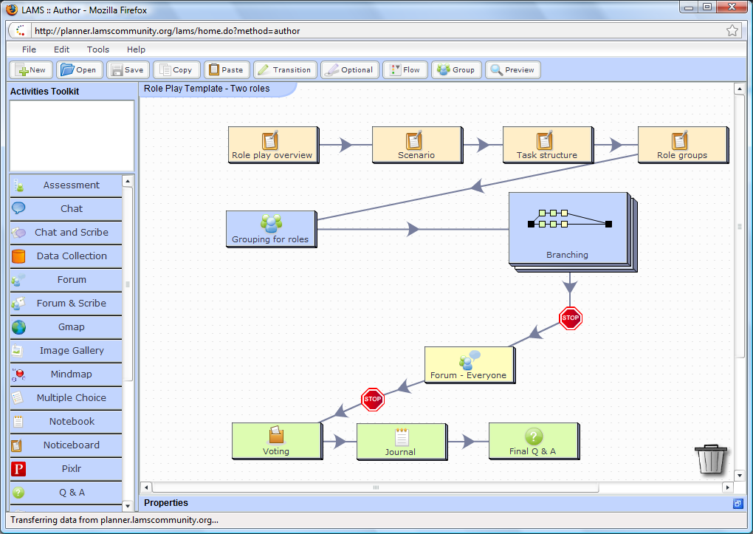
Figure 2: Template for Role Play shown in LAMS Authoring environment

Part 1 - Steps 1-4: [Text pages]
Overview and instructions for role play. Step 2 requires the lecturer to describe the scenario for the role play.

Part 2 – Steps 5 & 6a, 6b, 6c “Pre Role Play”
Step 5: Random allocation of students to role groups (for or against)
NB: Steps 6a, 6b & 6c are in private branches (according to allocated role)
Step 6a: Reflective Notebook/Journal for initial thoughts about allocated role in the given scenario
Step 6b: Question & Answer about initial thoughts on role
Step 6c: Discussion forum for further discussion of role among others in role group

[Stop point – released by lecturer after appropriate amount of time depending on synchronous/asynchronous mode of delivery. Students cannot progress past this point under released by lecturer.]

Part 3 – Step 7 “Role Play Proper”
Step 7: Discussion forum for all students – each student posts their initial views to their role thread, and then continues discussion/debate across threads as ideas develop.

[Stop point – released by lecturer after appropriate amount of time depending on synchronous/asynchronous mode of delivery. Students cannot progress past this point under released by lecturer.]

Part 4 – Step 8, 9 & 10 “Post Role Play”
Step 8: Voting tool – student steps out of role and decides his/her own view for or against
Step 9: Private Notebook/Journal – student reflects privately on what he/she has learned
Step 10: Question & Answer – students debrief by sharing what they found interesting or surprising from the activity.

While this sequence takes more time and preparation than the first example, it provides an opportunity for student centred learning through deep engagement with complex issues, particularly where students need to consider views other than their personal views. While the sequence is simple to edit (only the Scenario description is required editing), care is needed in the crafting of the scenario (to ensure it provides a good topic for discussion and debate across the roles). Care is also needed in the facilitation of this sequence by the lecturer, including preparation of students before starting the sequence, monitoring of discussion and timing of the release of “Stop points”. However, when used well, this sequence can be very effective at helping students to think more deeply about a difficult or controversial topic.

A “runnable” version of this sequence (for use in LAMS) is available from:
http://www.lamscommunity.org/lamscentral/sequence?seq_id=924470

Summary of Case Studies of LAMS implementation

LAMS has been used to implement a Learning Design approach in many countries, including Australia, Japan, the United Kingdom and Singapore. For case studies of specific disciplines or institutions, see papers and presentations from the various LAMS and Learning Design conference held from 2006 onwards (links to individual conferences available at http://www.lamsfoundation.org/conferences.htm - see each conference’s Program area for presentations, including audio and slides in most cases).

Some examples of the use of LAMS applicable to the templates described in this paper include questions in statistics lectures in Australia (Bilgin & Petocz, 2006), teaching of engineering with video and interactive questions in Singapore (Gagnon, 2007) and its use in role plays for teacher training (Dalziel, 2008). For an example of the use of online collaborative activities using LAMS in Japan, see Yamazumi & Yoshida (2008).

Conclusion

Learning Design provides a framework for describing and sharing effective templates for student centred learning. Learning Design systems (such as LAMS) provide a way to create and share sequences among educators and implement them with students. This paper has discussed two Learning Design exemplars which illustrate collaborative learning, and these exemplars can be adapted to a range of discipline contexts.

References

Agostinho, S, Oliver, R., Harper, B., Hedberg, H., & Wills, S. (2002). A tool to evaluate the potential for an ICT-based learning design to foster "high-quality learning". In A. Williamson, C. Gunn, A. Young., & T. Clear (Eds.), Winds of change in the sea of learning. Proceedings of the 19th Annual Conference of the Australasian Society for Computers in Learning in Tertiary Education. (pp. 29-38). Auckland, New Zealand: UNITEC Institute of Technology. Retrieved on 21st December from http://www.learningdesigns.uow.edu.au/project/doc/ASCILITE02.pdf

Bilgin, A. and Petocz, P. (2006). LAMS and statistics pedagogy. The First International LAMS Conference 2006: Designing the Future of Learning. Retrieved on 21st December from http://lams2006.lamsfoundation.org/pdfs/Bilgin_and_Petocz_LAMS06.pdf

Conole, G. (2009). Learning design at the OU – visualising, guiding and sharing designs. Keynote Presentation for the 2009 European LAMS and Learning Design Conference, Milton Keynes, UK, 7th July 2009. Retrieved on 21st December from http://lams2009.lamsfoundation.org/abstract.htm#ou

Dalziel, J. R. (2003). Implementing Learning Design: The Learning Activity Management System (LAMS). G.Crisp, D.Thiele, I.Scholten, S.Barker and J.Baron (Eds), Interact, Integrate, Impact: Proceedings of the 20th Annual Conference of the Australasian Society for Computers in Learning in Tertiary Education, 593-596. Adelaide, 7-10 December 2003. Retrieved on 21st December 2009 from http://www.ascilite.org.au/conferences/adelaide03/docs/pdf/593.pdf

Dalziel, J. (2007). Building communities of designers. In Rethinking pedagogy for a digital age: designing and delivering e-learning by H. Beetham & R. Sharpe. Routledge: London.

Dalziel, J. (2008). Powerful LAMS Versus Simple LAMS - The Challenge of Pleasing Everyone.
Presentation for the 2nd International LAMS Conference, Sydney, November 26th, 2007. Retrieved on 21st December 2009 from
http://lams2007sydney.lamsfoundation.org/slides/JD_2ndInternationalLAMSconference.DalzielKeynote.ppt

Gagnon, P. (2007). LAMS and the 4Ps: Pedagogy, Performance, Promise and Pragmatics. Presentation for the 2nd International LAMS Conference, Sydney, November 26th, 2007. Retrieved on 21st December 2009 from http://lams2007sydney.lamsfoundation.org/slides/LAMS_PG.ppt

IMS (2003). Learning Design Specification. Retrieved on 21st December from http://www.imsglobal.org/learningdesign/

Koper, R. (2001). Modeling units of study from a pedagogical perspective: the pedagogical meta-model behind EML. Retrieved on 21st December from http://dspace.ou.nl/handle/1820/36

McLaughlan R.G., Kirkpatrick D., Hirsh, P. and Maier H.R. (2001). Academic and institutional issues related to the planning and implementation of a multi-disciplinary role-play-simulation involving collaboration across institutions. In Kennedy, G et al (Eds) Meeting at the crossroads: Proceedings of the 18th annual conference of the Australian Society for Computers in Learning in Tertiary Education (pp. 407-415). Melbourne: Biomedical Multimedia Unit, University of Melbourne. Retrieved 21st December 2009 from http://www.ascilite.org.au/conferences/melbourne01/pdf/backup/mclaughlanr.pdf

Yamazumi, T. & Yoshida, S. (2008). Using LAMS for collaborative learning - Case research and exchange of opinions on crimes committed through computer networks. Presentation for the 3rd International LAMS & Learning Design Conference, Sydney, Australia, December 5th, 2008. Retrieved on 21st December from
http://lams2008sydney.lamsfoundation.org/abstracts.htm#15 and http://lams2008sydney.lamsfoundation.org/audio/Room4-Rm103/1008.MP3

