Here are some mainly language related items. If you have any questions: uwe.wennmann@gmx.net

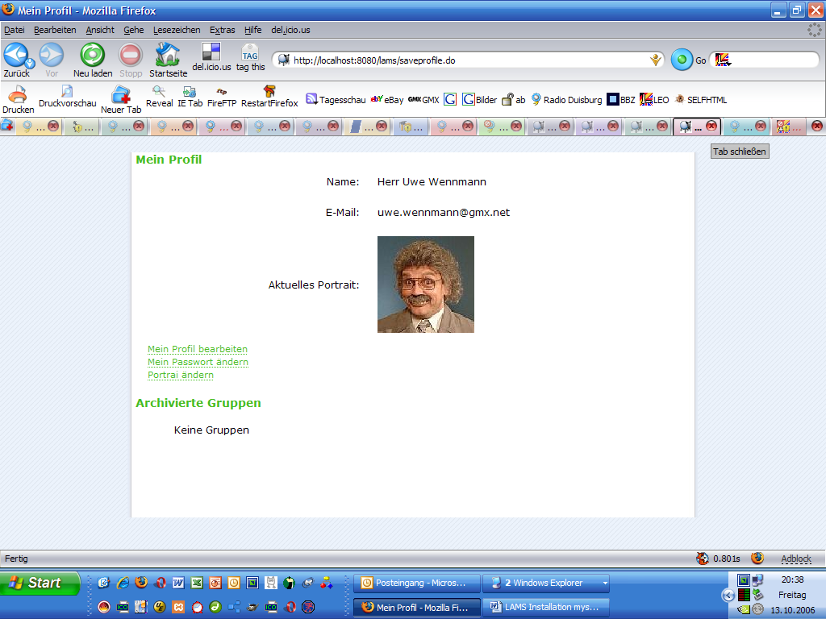

“Portrait ändern” instead of „Portrai ändern”

Bug: The pictures quality isn’t ok. viewed in gimp, it’s better. Why?

There is no back-button. (Many windows don’t show a back-button.)

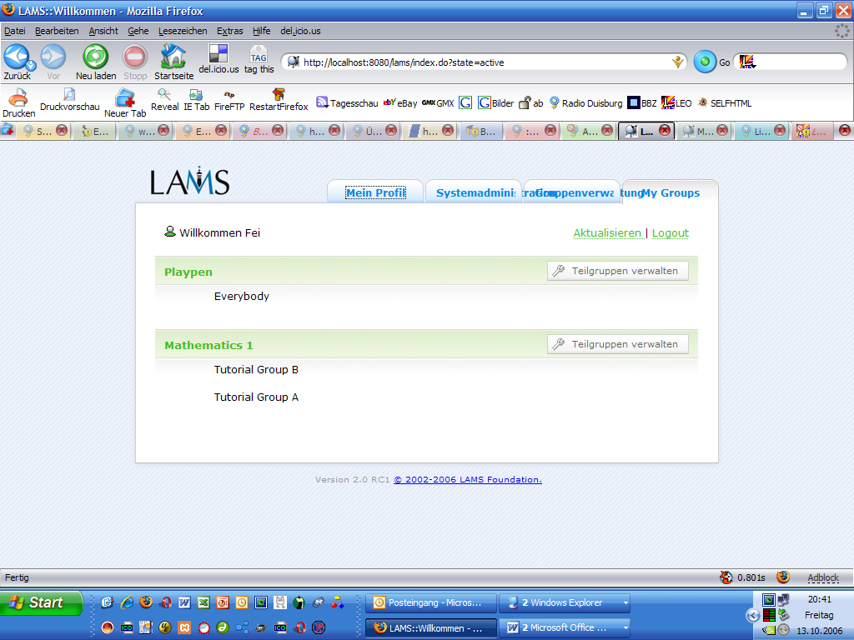

Look at the blue text. It’S too long for the content.
There is no back-button.

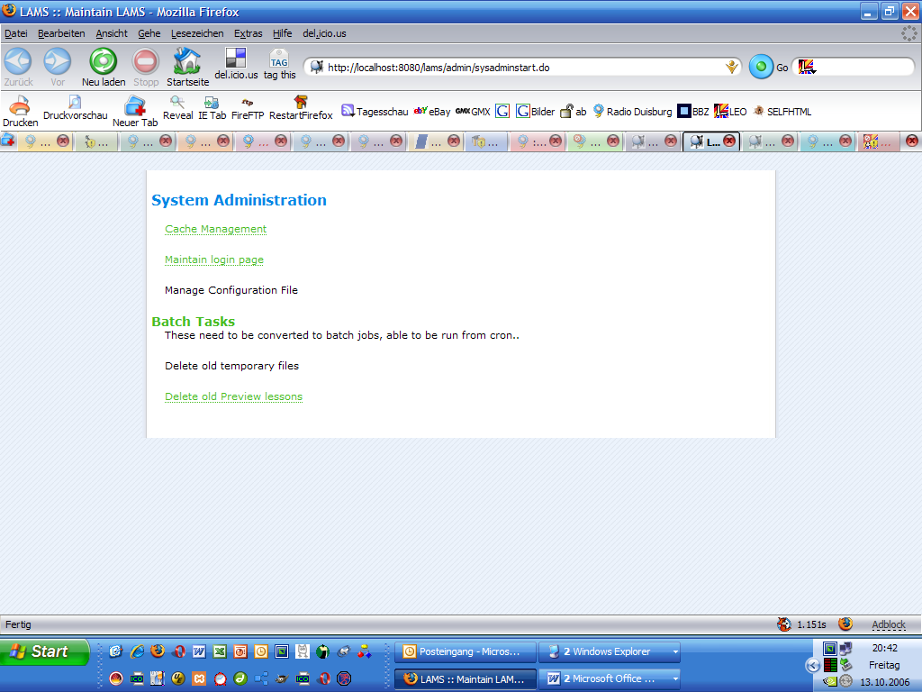

„Anpassen der login-Seite“ instead of “Maintain login page”

„Stapelverarbeitung“
„Diese Aufträge müssen in Stapelverarbeitungsaufträge umgewandelt werden, damit sie von cron aufgerufen werden können.“ instead of „batch Tasks”

Lösche alte temporäre Dateien.

Lösche alte Vorschau-Dateien.

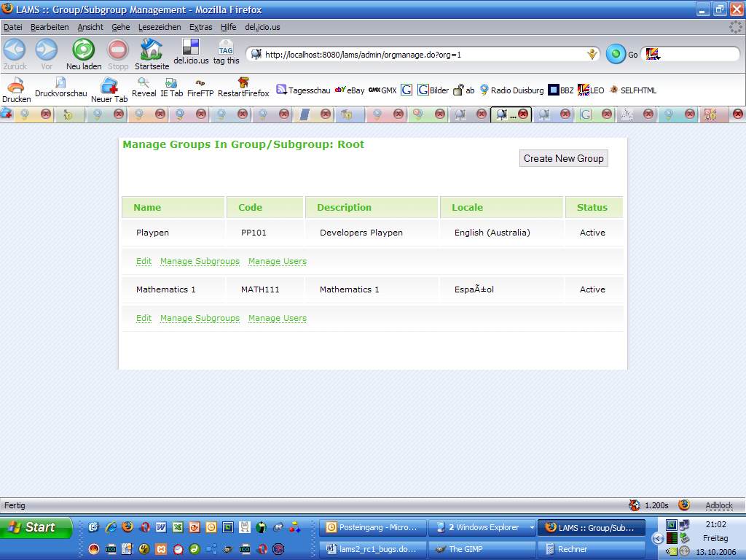

“Neue Gruppe anlagen” instead of “Create New Group“

„Name Kurzbezeichnung Beschreibung Sprache Status“

“Ändern” instead of “Edit”

„Anlegen und ändern von Teilgruppen“ instead of „Manage subgroups“

„Anlegen und ändern von Benutzern“ instead of „Manage users“
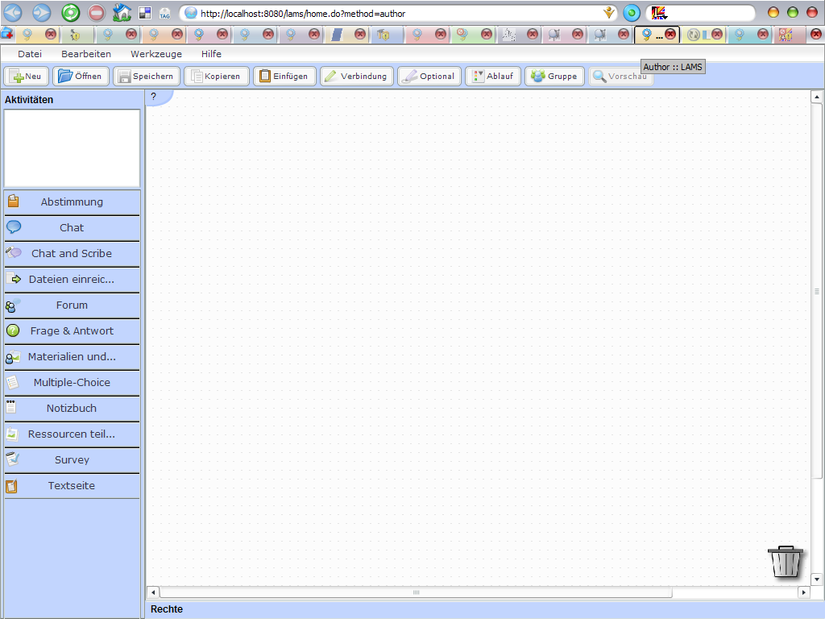

“Befragung” or “Fragenkatalog” instead of “Survey”
„Werkzeug zur Erstellung von Umfragen.“

„Chat und „ instead of „Chat and Scribe“

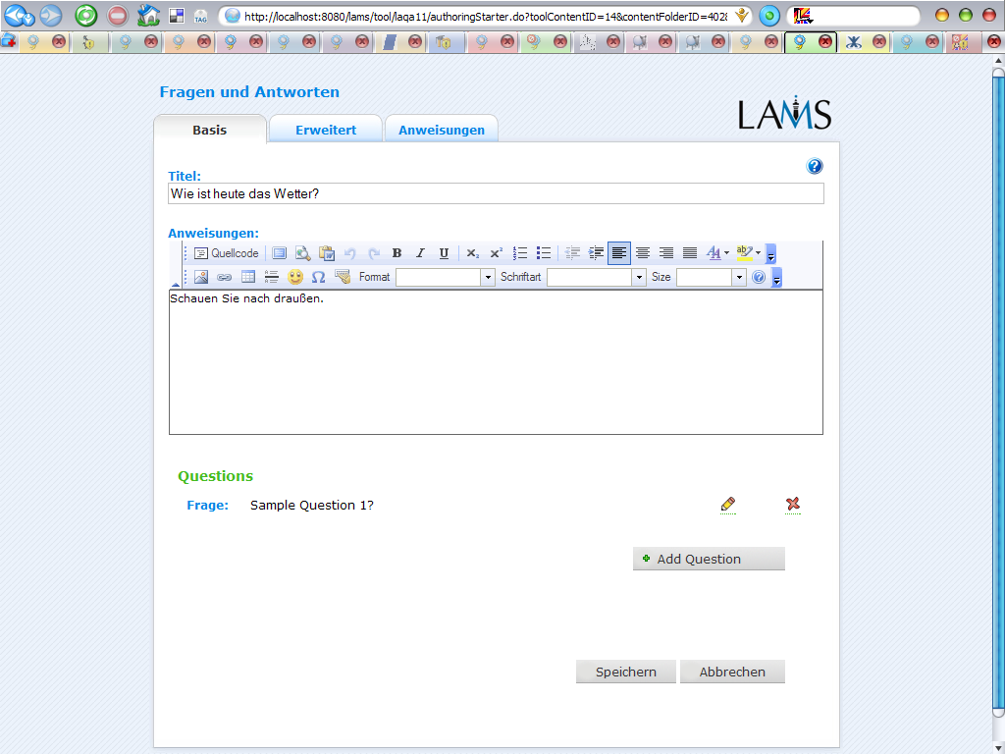

Bug: If I open a document, I don’t see the files I stored before.
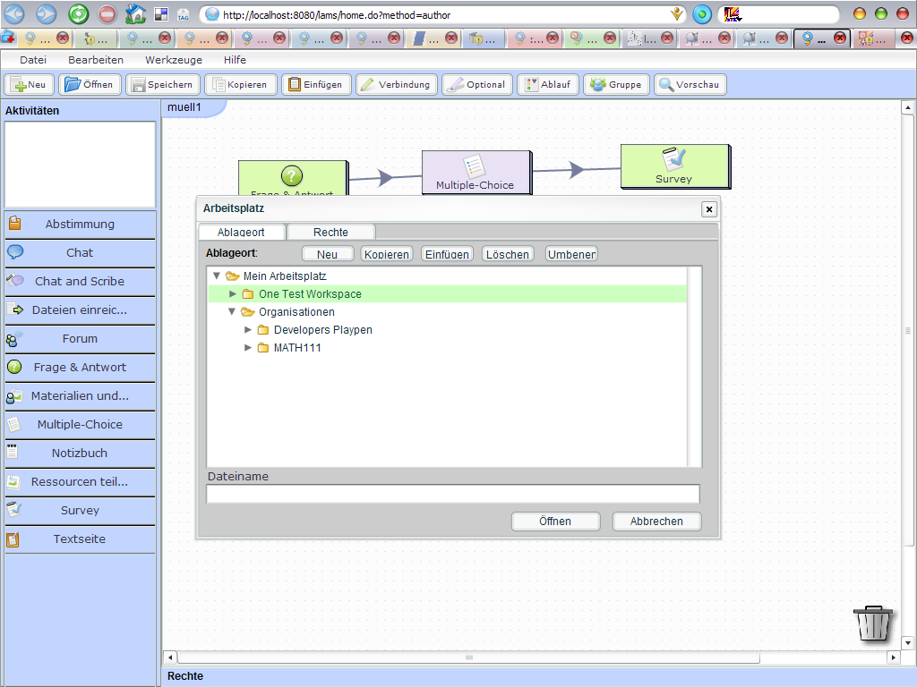

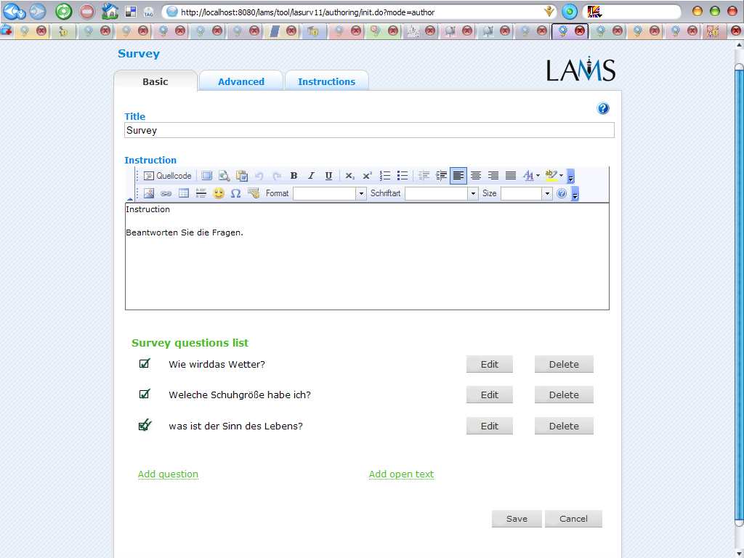

Bug: You have to click twice on “add question” to add another question.

“Ändern” instead of “Edit”
“Löschen” instead of “Delete”
“Speichern”
“Abbrechen”

“Befragung“
“Anweisung”
„Liste der erstellten Fragen „

„Frage hinzufügen“
„Freien Text hinzufügen.“

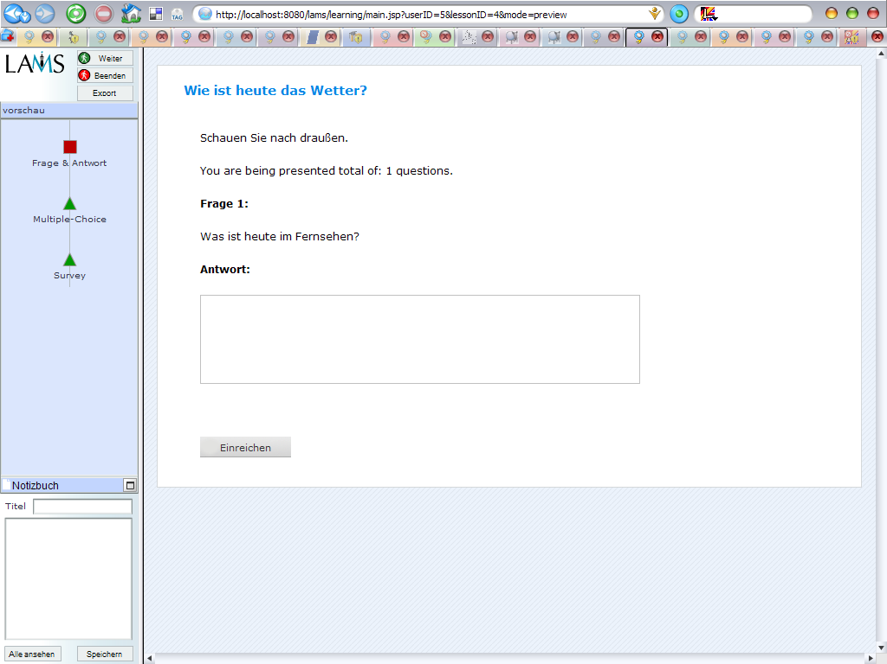

If only one question follows:
Ihnen wird eine Frage gestellt.

If more than one question follows:
Ihnen werden x Fragen gestellt.

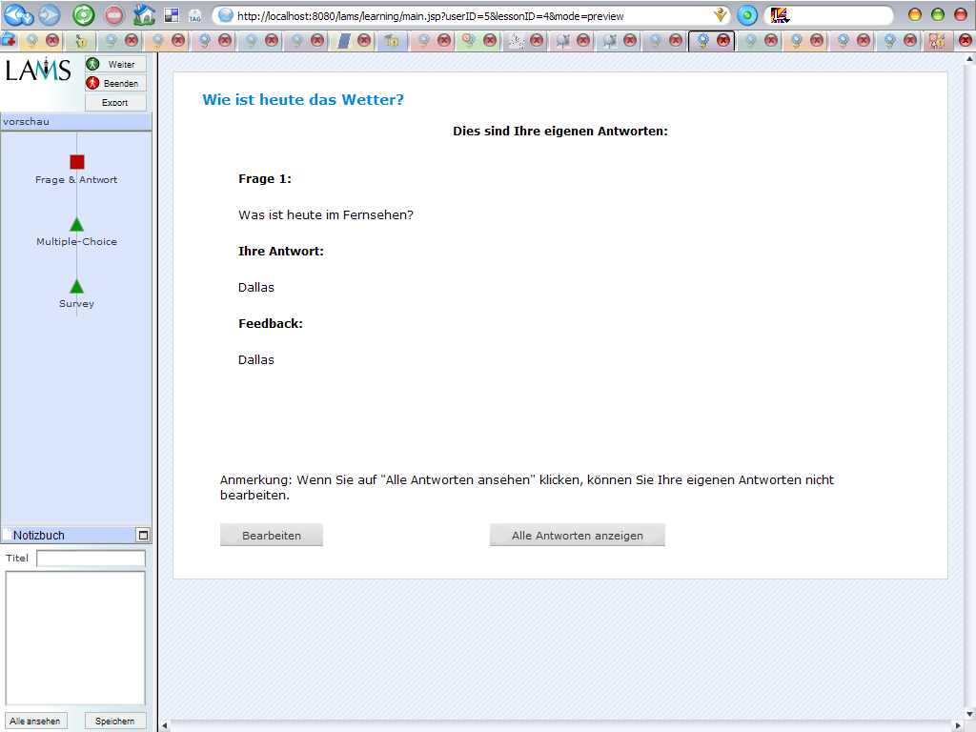

„Eigene Antwort korrigieren“ instead of „Bearbeiten“.

Die Antworten der anderen anzeigen.

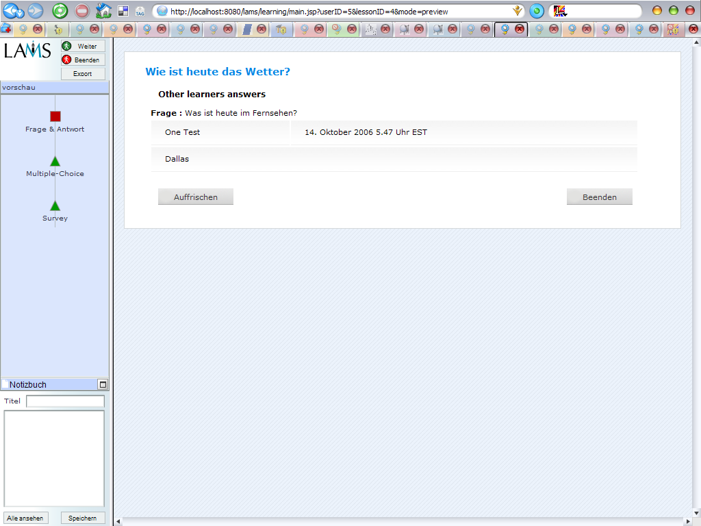

„Die bislang von anderen Lernern eingegangenen Antworten.“ statt „Other learners answers“
„Ansicht aktualisieren“ statt „auffrischen“.

Bug: The timezone is incorrect to germany.

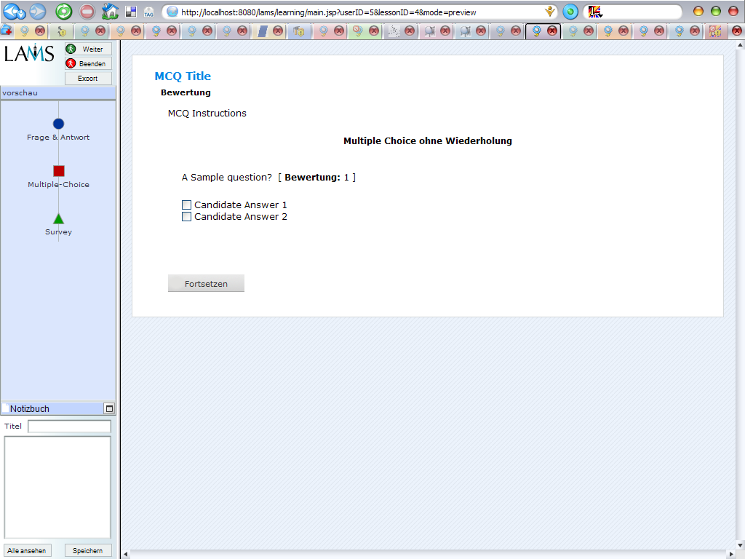
„Erläuterungen zu den Multiple Choice Fragen“ instead of „MCQ Instructions“

„Fertig“ statt „done“

„Fragen wiederholen“ instead of„retake survey“

“ Befragung beenden” statt “Finished”.

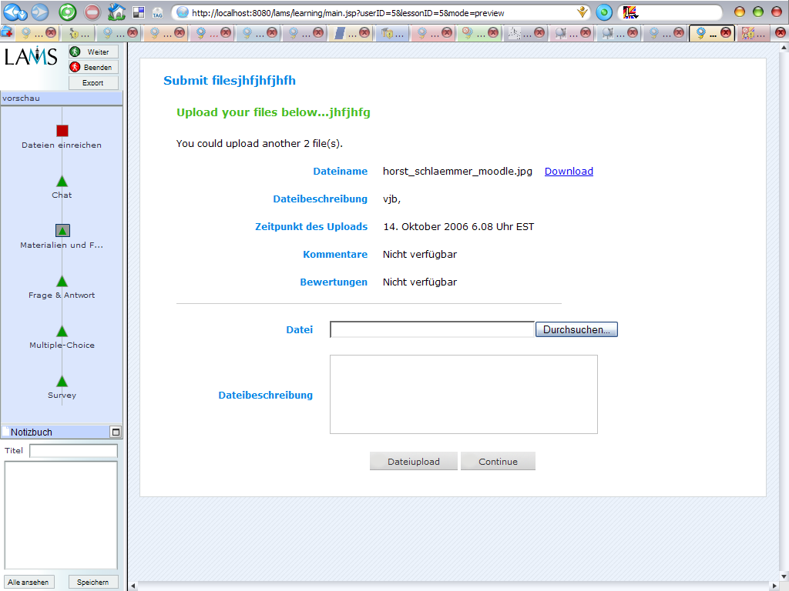

Dateien einreichen
Heraufladen der unten aufgeführten Dateien
Sie können x weitere Datei(en) heraufladen.

„Weiter“ statt „Continue“

Bug: Chat doesn’t run.

Couldn't connect. Please try again...
Code: 503
Type: cancel
Condition: service-unavailable

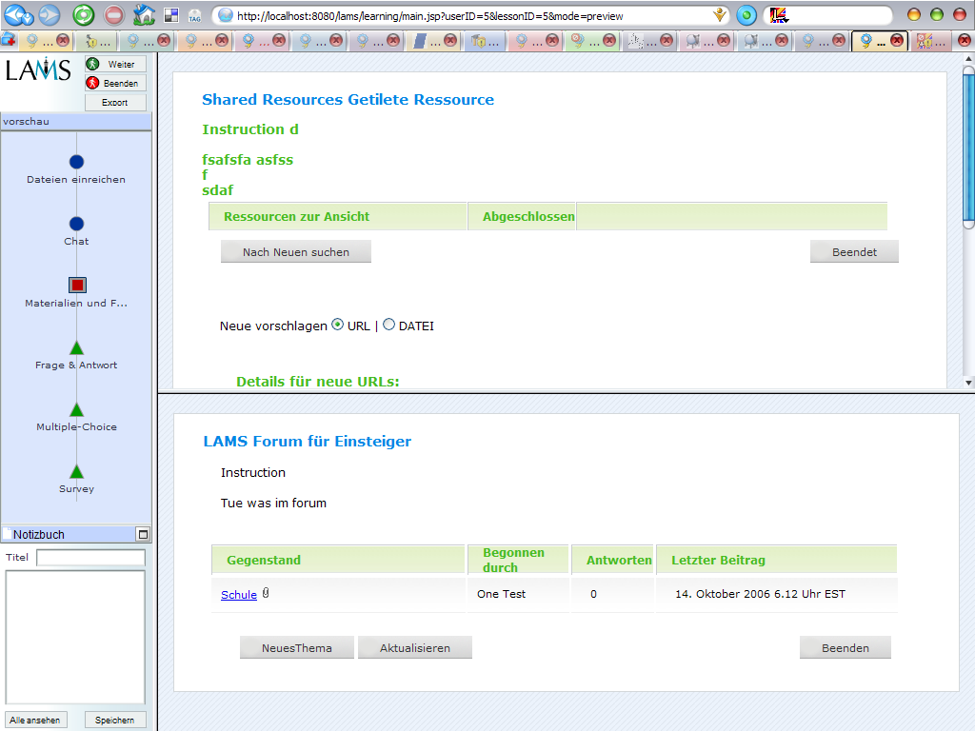

“Geteilte Ressourcen” instead of “Shared Resources Getitilete Ressource”
“Beenden” instead of “Beendet.”

Sometimes I got not reproducable errors, like this (and others):

java.lang.NullPointerException: Unknown runtime exception! Details verbergen java.lang.NullPointerException at org.lamsfoundation.lams.tool.rsrc.web.action.LearningAction.saveOrUpdateItem(LearningAction.java:313) at org.lamsfoundation.lams.tool.rsrc.web.action.LearningAction.execute(LearningAction.java:103) at org.apache.struts.action.RequestProcessor.processActionPerform(RequestProcessor.java:419) at org.apache.struts.action.RequestProcessor.process(RequestProcessor.java:224) at org.apache.struts.action.ActionServlet.process(ActionServlet.java:1194) at org.apache.struts.action.ActionServlet.doGet(ActionServlet.java:414) at javax.servlet.http.HttpServlet.service(HttpServlet.java:697) at javax.servlet.http.HttpServlet.service(HttpServlet.java:810) at org.apache.catalina.core.ApplicationFilterChain.internalDoFilter(ApplicationFilterChain.java:252) at org.apache.catalina.core.ApplicationFilterChain.doFilter(ApplicationFilterChain.java:173) at org.lamsfoundation.lams.web.filter.LocaleFilter.doFilterInternal(LocaleFilter.java:130) at org.springframework.web.filter.OncePerRequestFilter.doFilter(OncePerRequestFilter.java:77) at org.apache.catalina.core.ApplicationFilterChain.internalDoFilter(ApplicationFilterChain.java:202) at org.apache.catalina.core.ApplicationFilterChain.doFilter(ApplicationFilterChain.java:173) at org.lamsfoundation.lams.web.session.SystemSessionFilter.doFilter(SystemSessionFilter.java:66) at org.apache.catalina.core.ApplicationFilterChain.internalDoFilter(ApplicationFilterChain.java:202) at org.apache.catalina.core.ApplicationFilterChain.doFilter(ApplicationFilterChain.java:173) at org.springframework.orm.hibernate3.support.OpenSessionInViewFilter.doFilterInternal(OpenSessionInViewFilter.java:174) at org.springframework.web.filter.OncePerRequestFilter.doFilter(OncePerRequestFilter.java:77) at org.apache.catalina.core.ApplicationFilterChain.internalDoFilter(ApplicationFilterChain.java:202) at org.apache.catalina.core.ApplicationFilterChain.doFilter(ApplicationFilterChain.java:173) at org.jboss.web.tomcat.filters.ReplyHeaderFilter.doFilter(ReplyHeaderFilter.java:81) at org.apache.catalina.core.ApplicationFilterChain.internalDoFilter(ApplicationFilterChain.java:202) at org.apache.catalina.core.ApplicationFilterChain.doFilter(ApplicationFilterChain.java:173) at org.apache.catalina.core.StandardWrapperValve.invoke(StandardWrapperValve.java:213) at org.apache.catalina.core.StandardContextValve.invoke(StandardContextValve.java:178) at org.jboss.web.tomcat.security.CustomPrincipalValve.invoke(CustomPrincipalValve.java:39) at org.jboss.web.tomcat.security.SecurityAssociationValve.invoke(SecurityAssociationValve.java:153) at org.apache.catalina.authenticator.AuthenticatorBase.invoke(AuthenticatorBase.java:482) at org.apache.catalina.authenticator.AuthenticatorBase.invoke(AuthenticatorBase.java:482) at org.jboss.web.tomcat.security.JaccContextValve.invoke(JaccContextValve.java:59) at org.apache.catalina.core.StandardHostValve.invoke(StandardHostValve.java:126) at org.apache.catalina.valves.ErrorReportValve.invoke(ErrorReportValve.java:105) at org.lamsfoundation.lams.integration.security.SingleSignOn.invoke(SingleSignOn.java:121) at org.lamsfoundation.lams.integration.security.LoginRequestValve.invoke(LoginRequestValve.java:67) at org.apache.catalina.valves.FastCommonAccessLogValve.invoke(FastCommonAccessLogValve.java:481) at org.apache.catalina.core.StandardEngineValve.invoke(StandardEngineValve.java:107) at org.apache.catalina.connector.CoyoteAdapter.service(CoyoteAdapter.java:148) at org.apache.coyote.http11.Http11Processor.process(Http11Processor.java:856) at org.apache.coyote.http11.Http11Protocol$Http11ConnectionHandler.processConnection(Http11Protocol.java:744) at org.apache.tomcat.util.net.PoolTcpEndpoint.processSocket(PoolTcpEndpoint.java:527) at org.apache.tomcat.util.net.MasterSlaveWorkerThread.run(MasterSlaveWorkerThread.java:112) at java.lang.Thread.run(Thread.java:595)

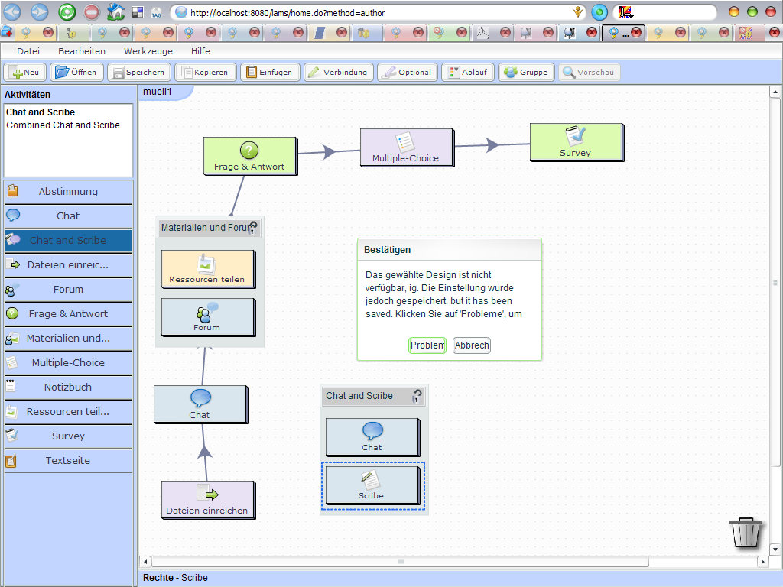

Panel-text is incomplete translated.

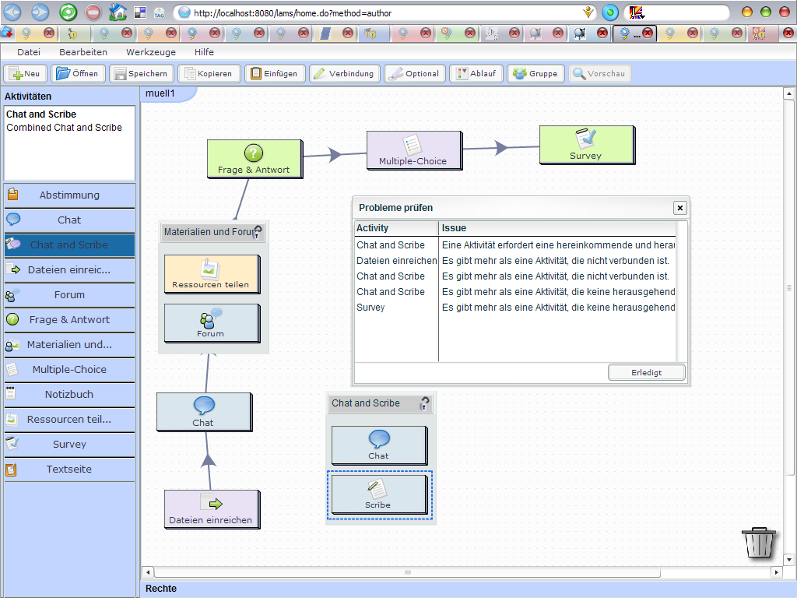

Text isn’t visible, because the panel is too short.

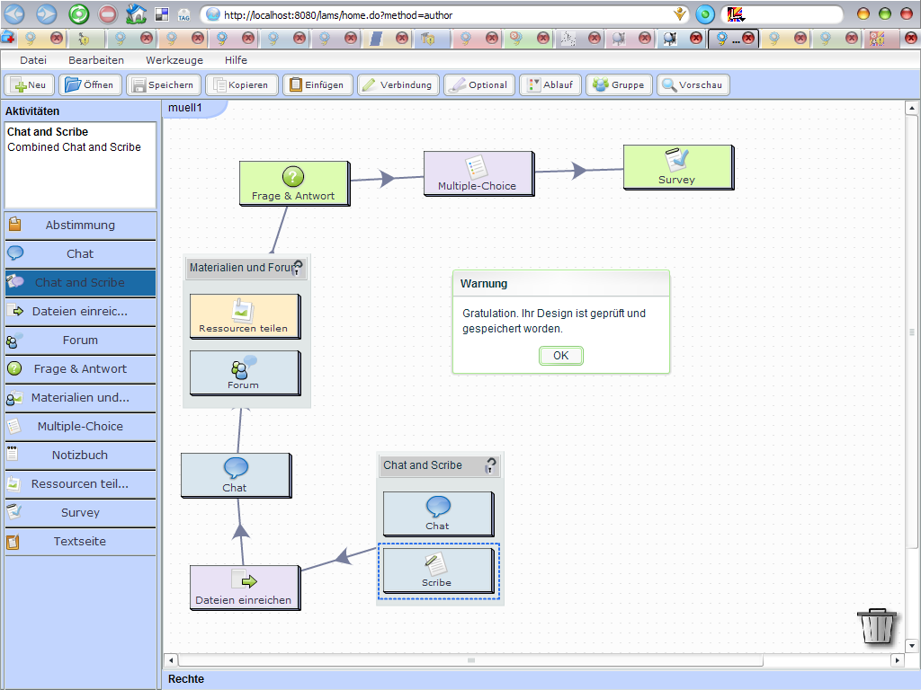
No “Gratulation.” Better: “OK”.

If I click on Export I get a blue text and a green text, which mean the opposite of each other:
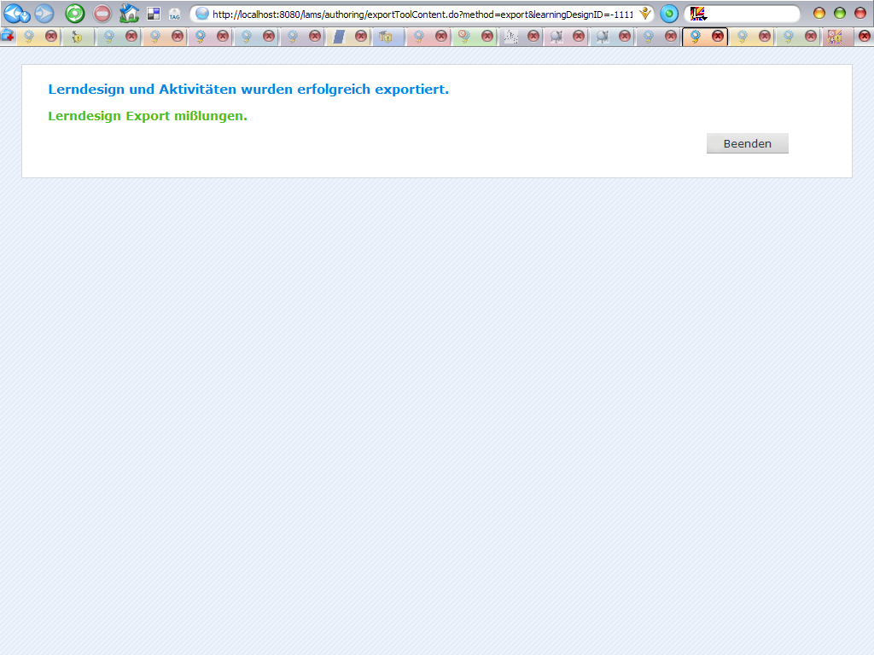

Bug?: When I export from File Menu, I get an other file than from preview. Is that right?

Another, not reproducible bug:

java.lang.IllegalArgumentException: sessionMapID is required 'null' Details verbergen java.lang.IllegalArgumentException: sessionMapID is required

