1: After uploading image to server, attempt to put it in to WYSIWYG editor fails

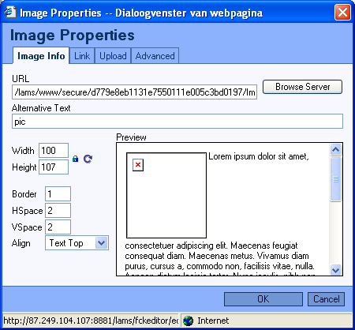

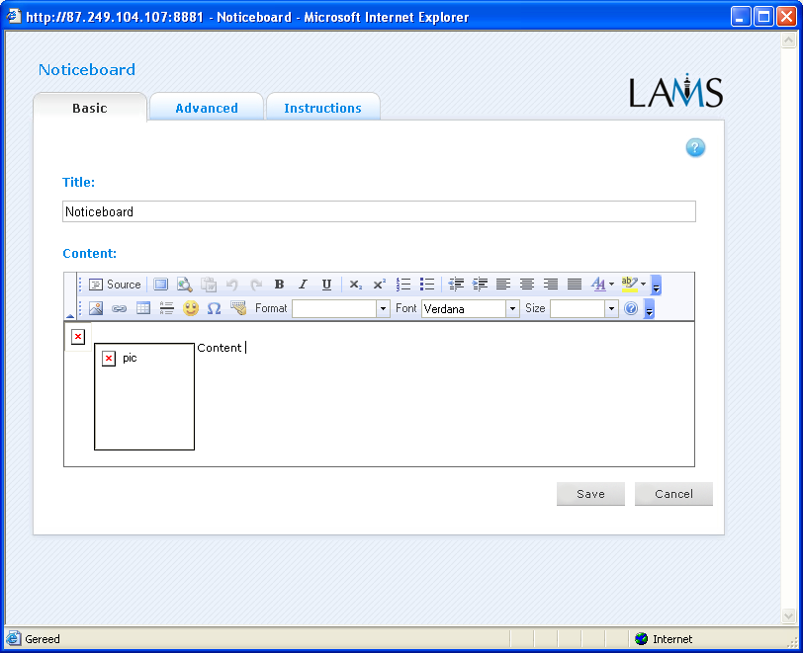

2: Trying to put a picture on the login screen fails: browse server generates error message

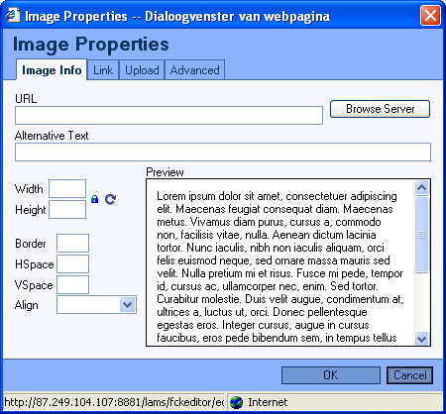

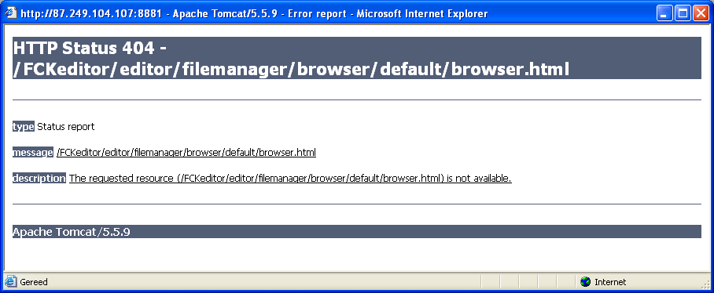

sending to server fails here, screen stays like it is after pressing “send to server” (works normal in authoring environment)
