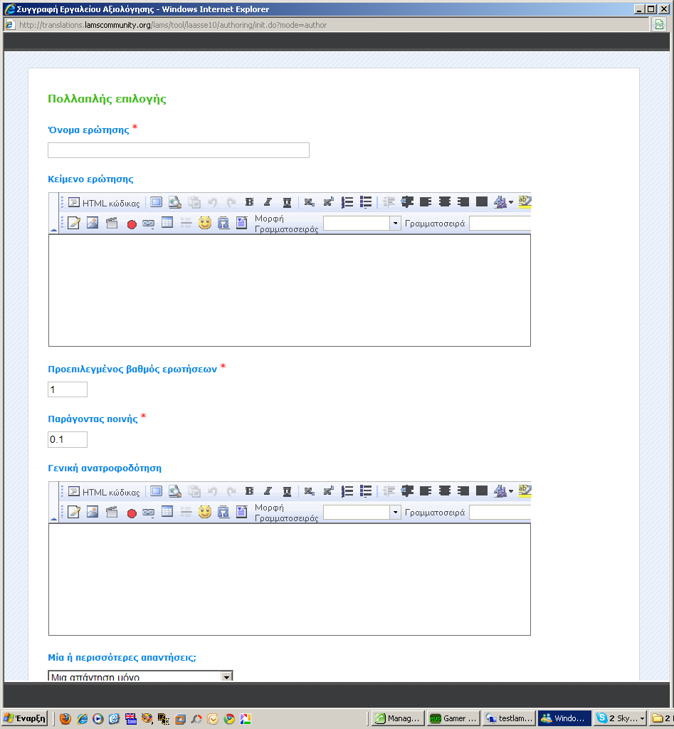
Assessment tool. There are problems at the end of Question's FCK Editor.
- In English version you cannot she the down arrow on Size dropdown menu
- In Greek version you cannot see the size drop down menu and anything else exist after it.
Please, increase the length of FCK Editor in all type of questions!
